Stephen W. Wolf
27132 Butternut Ridge Road
North Olmsted, Ohio 44070-4417

April 7, 2005

Mr. John Hunter
Ohio State Parks
2045 Morse Road Building C3
Columbus, Ohio 43229

Mr. Hunter,

I am writing in regard to the process used by Spherix Incorporated to reserve sites at the Ohio State Park campgrounds. I believe that Spherix Incorporated has designed software to mislead good-intentioned people and then profits by that deception. The State of Ohio is a party through their contractual relationship with Spherix Incorporated

On Wednesday, April 7, 2005, a beautiful spring weekend was forecast; my family made plans to camp at the Punderson State Park campground. We camped there twice during the 2004-2005 winter season. Both times I knew that the upper loops were closed, traffic was light, and going to the park to choose a site was to be the appropriate course. This time, due to the nice spring weather, I worried about crowding and hoped the upper loops were open. I decided to spend the extra $8.00 to reserve a proper site. I have a motorhome and few of Punderson’s hilly sites meet my specifications. I went to the Spherix Incorporated site, chose the map of the upper loops, saw many were listed as available (in green, see the attached map copied on Thursday, April 7, 2005). It appeared to me from the map that a good number of sites were taken. I even changed my camper type around to try to determine if a campsite was truly occupied. It appeared quite a few people were using the park during the time we were to stay there. I was happy the upper loop was open. I clicked on site 142, hit “add to cart”, and proceeded to pay for the site. I arrived on Thursday, April 07, 2005 to find the upper loop closed and all sites were first-come, first-served. I had wasted $8.00 making the reservation. I was misled to believe these sites were open. In fact, the park was virtually empty and operating in first-come, first-served availability.

Spherix Incorporated is purposeful in their design of software that falsely lists site availability at Ohio State Parks. Spherix Incorporated is purposeful in their design of software that allows a user to select an unavailable site. Spherix Incorporated purposefully represents that site as available knowing, or should have known, that the site is closed. Spherix Incorporated allows a person to pay for that site by designing a pop-up caveat that is insufficient to ward off mistakes they had purpose or negligence in causing. Spherix Incorporated then profits off their deception. Free of that deception the user likely would proceed without their reservation depriving Spherix Incorporated of their unjust profit. These activities by Spherix Incorporated being perpetrated across all transactions and involve all users of the reservation system at the Ohio State Parks.

I called the 1-866-OHIOPARKS number and spoke to Billie. She commiserated with my dilemma but reported that once the reservation date arrived, they could do nothing to mitigate a problem. Her supervisor, Sue Hutzell, reported the same. I asked for the name of her company which she refused to provide. I was aghast that an Ohio State contractor refused to identify herself. I later traced the IP address to reserveworld.com and then to Spherix Incorporated Sue Hutzell reported I should take the issue up with Punderson management. I have camped in every one of the Ohio State Park campgrounds. I have come back to camp at many parks many times. I know that the last person I should complain to is a park manager who has all he or she can do without my complaint. The manager would have no solution. You appear to be the link between the State of Ohio and the software of Spherix Incorporated

Spherix Incorporated will argue that their reservation system allows even an off-season user a site at a particular park. In fact, that user has no better chance of getting a site if they have a reservation or came to the park without one. Users arrive to a closed office, choose their site, and set up camp. There is no method by which the park could “reserve” a site for a Spherix Incorporated user. There are no sites held in reserve should someone reserve them. The rangers report to me that there is no process in which they monitor an almost full park to satisfy reservists. This argument is a deception designed to induce the payment of fees to Spherix Incorporated.

I am asking that in light of the behavior by Spherix Incorporated my $8.00 reservation fee be refunded. I will then retire to camp again knowing the pitfalls of the process.

I am asking you to seriously consider demanding changes to this software so that it properly represents correct site availability. I ask you to consider a change to allow a clear message that is designed to ward off those who can come in the off-season to almost any Ohio State Park on a far majority of days to find sites on a first-come, first-served basis that would make the $8.00 fee they are charged a waste of their money. I have included a suggested pop-up box. I ask you to require Spherix Incorporated to identify themselves in a manner that allows a user to understand the link between Spherix Incorporated and the State of Ohio.

Please be assured my purpose is not really to recover the $8.00 but in protecting the reputation of the State of Ohio and my Ohio State Park system. Thank you for your consideration, I remain,

Sincerely,

Stephen W. Wolf

Cc: Spherix Incorporated
12051 Indian Creek Court
Beltsville, Maryland 20705

Attached: Copy of park map showing deceptive availability
Copy of reservation confirmation

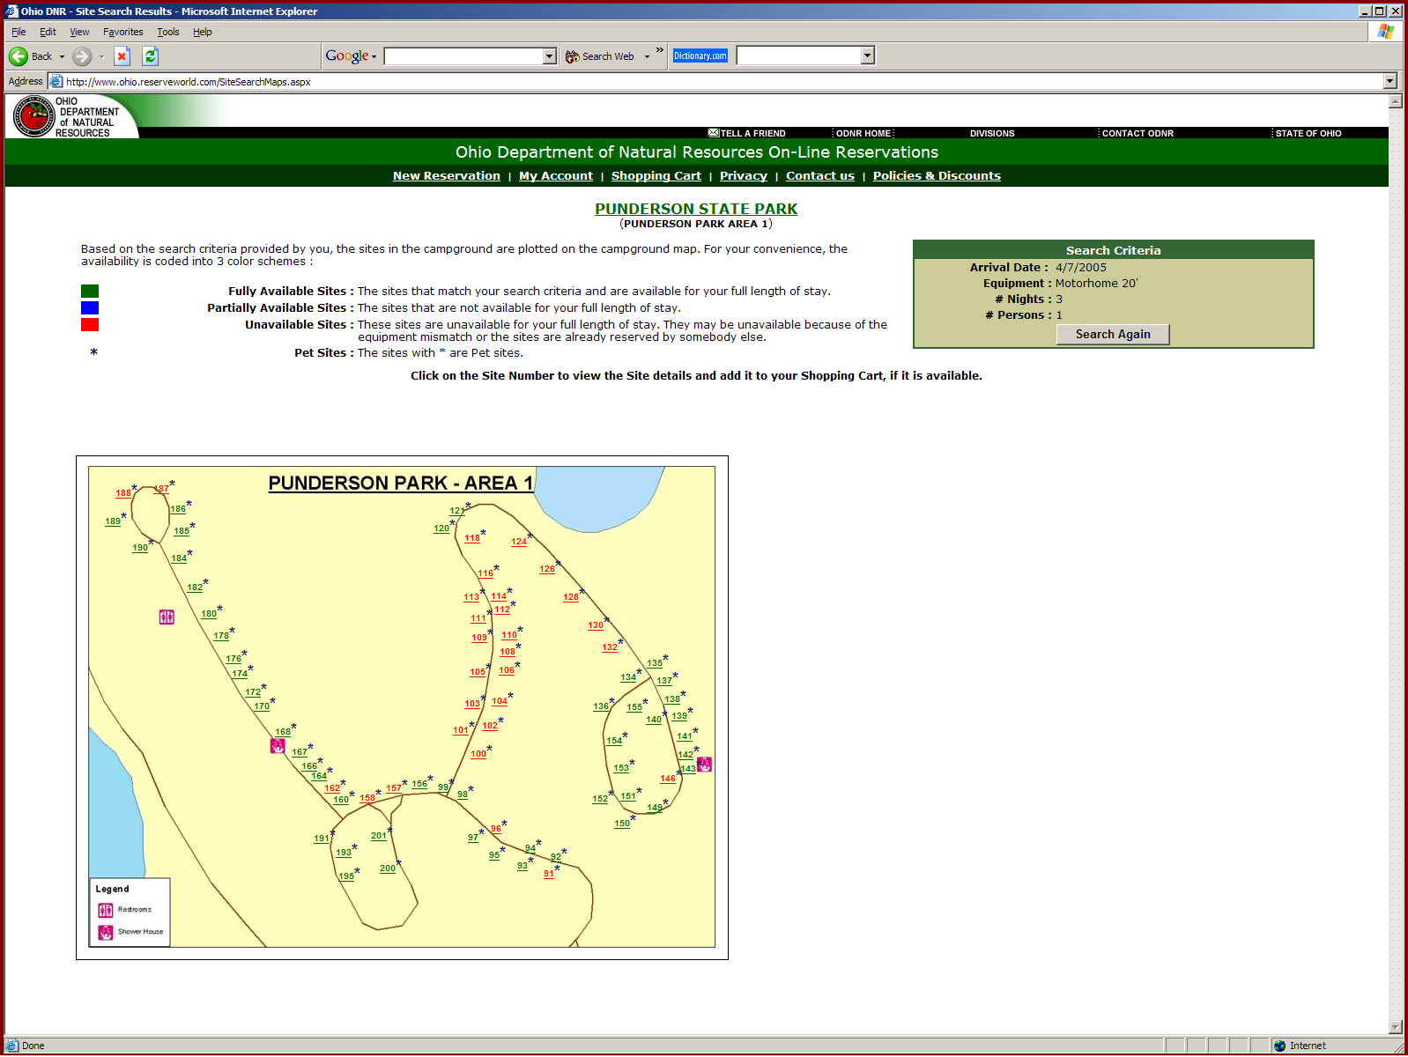

The above was copied on April 7, 2005. It shows sites known to be closed as being “Fully Available”. It implies that the sites in red represent sites which are not available due to their being occupied and implies the park does have a number of campers on site when, in fact, the loops are closed.

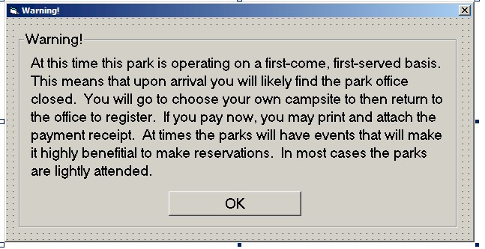

The above is a simple, plain warning to users that would better inform them of the process in which they are about to embark.

